Name
Date
Activity number

TYPE/  PROPERTIES | Structure | Specific function | Shape | Quantity | Color | Granular/ agranular
Monocytes | 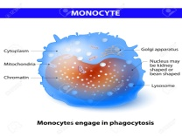 | Innate immune system component | Spherical | 200-600 per blood microliter | Blue-gray | Agranular
Lymphocytes | 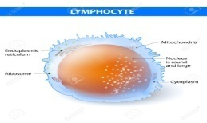 | Anti-body production | Spherical | 1000-4800 in 1µL | Pale-blue | Agranular
Neutrophils | 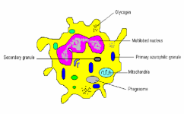 | Bacterial and fungal infections protection | Spherical | 4500-11000 per mm³ | Pink | Granular
Basophils | 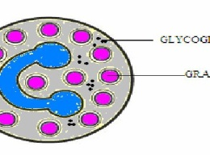 | Fighting infections | Round | 0-3 in 1µL | Purple-black | Granular
Eosinophils | 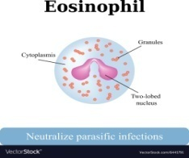 | Neutralizing parasitic infections | Pink | 30-350 | Light-blue | Granular
Red blood cells | 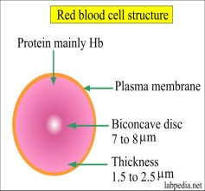 | Carrying oxygen to the rest of body from lungs | Biconcave disc | 20-30 trillion for adult humans | Scarlet | N/A
Platelets | 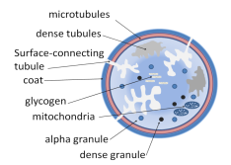 | Bleeding prevention | Irregular shape | 150000 to 450000 per blood microliter | Dark purple | Granular

References

Surgenor, D. M. N. (2014). The Red Blood Cell: Volume II. Saint Louis: Elsevier Science.

Bagge, U., Born, G. V. R., & Gaehtgens, P. (2013). White Blood Cells: Morphology and Rheology As Related to Function. Dordrecht: Springer Netherlands.

. https://public.ebookcentral.proquest.com/choice/publicfullrecord.aspx?p=5610288.

Missirlis, Y. F., & Wautier, J.-L. (1993). The Role of platelets in blood-biomaterial interactions. Dordrecht: Kluwer.

